Date:

Dear <MPs Name>

I’m a concerned citizen in your riding, and am writing to urge you to petition the Government to investigate the Jehovah’s Witnesses organization on a matter of public safety. Their lack of adequate child protection policies has resulted in the molestation of countless children. The organization’s dangerous policies also allow violent sexual predators to roam freely in society and escape our justice system. I support religious freedom, but I draw the line when children are endangered by sexual predators, or when criminals are allowed to act without consequence. Though the organization keeps meticulous records of every alleged case of abuse, they are involved in a massive cover up that keeps these abuse cases a secret and victims trapped.

We need a Government Inquiry for the following reasons:

- The Jehovah's Witnesses organization systematically fails to report cases of child abuse despite provincial mandatory reporting legislation.¹ Members who suspect child abuse are instructed to call their elders (church leaders), and the elders are told to immediately call their Legal Department, yet not the authorities.
- Canada should have only one judicial system. The Jehovah’s Witnesses organization has their own judicial system where violent criminals guilty of rape, molestation and other physical abuse are tried in secret. Jehovah’s Witness molesters and rapists NEVER go to prison since their policies enable them to escape Canada’s judicial system. They get no criminal record and maintain full access to children and those they have abused.
- Instead of calling the proper authorities, the organization’s judicial court governed by an all-male team of elders with no training in child welfare, subjects child victims of abuse to further trauma through intense probing. Valuable forensic evidence is also lost by delaying or not calling the proper authorities.
- The Jehovah's Witnesses organization employs a “Two Witness Rule”² that prevents them from reporting child abuse according to their own interpretation of their canonical law. All a molester has to do is deny or ignore the accusation of abuse, and no further action is taken by the organization. (see Appendix 1)
- The organization is controlled through a policy of shunning³ that prevents them from reporting abuse individually. Victims who spoke out against church leaders who were molesters have been punished with extreme shunning, where even their own families cut them off completely, leaving victims feeling handcuffed to report abuse. Victims within this group stand to lose everything and everyone should they speak out. This is not the case with other organizations making this situation unique.
- Children who are abused within the organization are not given any kind of rehabilitation, and not encouraged to seek professional help.
- Child molesters within their congregations, known only to a select few of their elders and their victims, are still required by the organization to preach publicly and recruit unsuspecting people at their houses. They have free access with no restrictions to children, anywhere, at any time.
- Victims of molestation within this group who are brave enough to speak out, can only report their abuse to elders who are all male, and can be subsequently judged by these men, who most times are friends of the abuser. There is no provision to come forward to women.

Many other countries like Australia, Germany, the UK, the Netherlands, and more are also investigating the child protection policies of the Jehovah’s Witnesses organization (policies put in place by their leaders in the U.S.A. that are CONTINUING to put our Canadian children in harm’s way.) The 2015 Royal Australian Commission into child sexual abuse within institutions concluded that this organization’s policies are seriously flawed as they do not adequately protect children, they have a history of not reporting sexual abuse crimes, and molesters go free, leaving the public at risk (please see attached findings in Appendix 2). The judge/chair who presided over their investigation said: “I don’t know of any other religious organization which has the processes with the flaws we have identified in the Jehovah’s Witnesses”.

I urge you to petition the Government to carry out this investigation. The Jehovah’s Witnesses organization is a Canadian charity that rakes in $70 million tax free annually, yet they have been nicknamed a pedophile’s paradise. Here all a molester has to do is deny any accusations of abuse and no further action is taken. They are thus sheltered from the law and are free to continue molesting more children. A Government inquiry can make a huge difference to protect Canadian children. Please render your much needed assistance! Kindly let me know if you need more information or if I can help in any way. I look forward to hearing from you on this most urgent matter. Thank you!
Yours sincerely,
<Your name>
Attach.

¹ Non Reporting
While each province has its own mandatory reporting legislation, the Jehovah's Witnesses organization systematically fails to report in any province, and also, according to their own policy and procedure, they fail to report worldwide. The recent W5 documentary, 'No Witness' aired on March 24th, 2018 on CTV (https://www.youtube.com/watch?v=13ja8dMEmPY) revealed at least three cases of child abuse that Jehovah's Witness elders (i.e. church leaders) were informed of, but failed to report to the relevant authorities. In at least one case, the abusee was also actively discouraged from reporting the issue personally.
The 2015 Australian Royal Commission (https://www.childabuseroyalcommission.gov.au/case-studies/case-study-29-jehovahs-witnesses) found records for 1006 alleged perpetrators in the Jehovah’s Witnesses organization’s records, but NOT ONE had been reported to the police. From 47 Jehovah's Witness perpetrators who have been convicted of child abuse between 1999 and 2018 in the UK (where a Government investigation is forthcoming), yet again NOT ONE was reported to the police by elders or active Jehovah's Witnesses.

The Jehovah's Witnesses organization treats child sexual abuse as a sin and not as a crime. When abuse is committed, instead of calling the police, they have been instructed over and over again to contact their organization’s Legal Department (see Appendix 3). The organization chooses to protect itself and its assets over children, and prefers to keep child sexual abuse hidden, to be handled within the organization. Three elders meet secretly to decide if abuse has occurred (though they have no training) and impose internal punishments. No congregation member is warned that a pedophile is in their midst. The abuser is then sheltered from prison, yet is still made to recruit new members in their door to door evangelism work, giving pedophiles access to people’s homes and children.

² The Two Witness Rule
The Jehovah's Witnesses organization strictly adheres to their “Two Witness Rule” which states that in the absence of two (credible) witnesses, the elders cannot deal with the alleged abuse. Since nearly every case of abuse is done in secrecy, there simply will not be a second witness to the crime. This is ludicrous! In the absence of a confession, and no second witness to the molestation, they “leave matters in Jehovah’s hands” (i.e. do nothing). Victims of abuse are then left feeling unbelieved with no recourse, re-victimized and stuck within the congregation with their molester (who sometimes is their own father). Despite all this, the organization stated publicly in their November 2017 online “JW Broadcast”, that they "will never change the Two Witness Rule". Elders counsel victims and parents to tell no one, issue no warnings to others, and punish those who do warn others, claiming they are causing divisions within the organization.
The organization fosters an atmosphere of fear and hatred for the outside world (this includes the authorities and all people and anything outside their organization) whom they believe is being led by Satan the Devil. They state outwardly in their publications that victims are free to go to the authorities, yet the facts show otherwise, and victims of abuse tell a different story. Their elders implore victims of abuse “not to take a brother to court”, and pressure them “not to bring reproach upon their God Jehovah” by reporting their abuser to the respective authorities. This has created what many have called a “pedophile’s paradise” where molesters are shielded from the law, from jail time, from having a criminal record, and giving them the ability to molest again and again. This is a threat not only within the Jehovah’s Witnesses organization, but to everyone.

³ Shunning Policy
The Jehovah's Witnesses organization employs the strict control mechanism of ‘shunning’ of any member of the congregation who chooses to leave for any reason, who is deemed to have gone against the group, or anyone who complains about organizational policy. This makes victims very reluctant to report abuse. People who are shunned lose their family and any support network had within the group. As congregants, they are not allowed to make friends with non-Jehovah's Witnesses, so the isolation for the survivor after disclosure is extreme which prompts many to stay silent. This results in Jehovah’s Witness victims being left unable to find out anything about abuse cases from which they might learn.
APPENDIX 1 – from the secret elders’ handbook: “Shepherd the Flock of God”

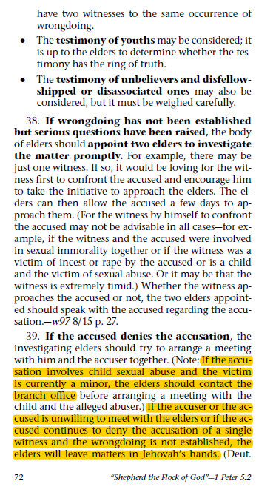
APPENDIX 2 – findings from the 2015 Australian Royal Commission

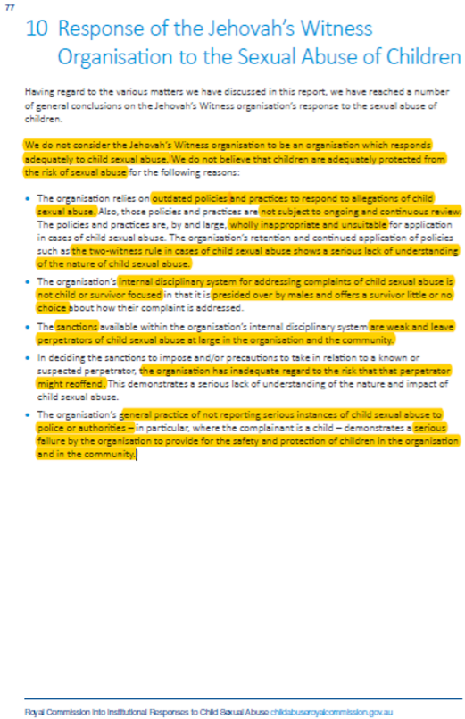
APPENDIX 3 – copy of a secret letter to all elders (church leaders) urging them to call their Legal Department. Never is anyone encouraged to call the authorities.

